2017 Hayden - Mecha Car Show

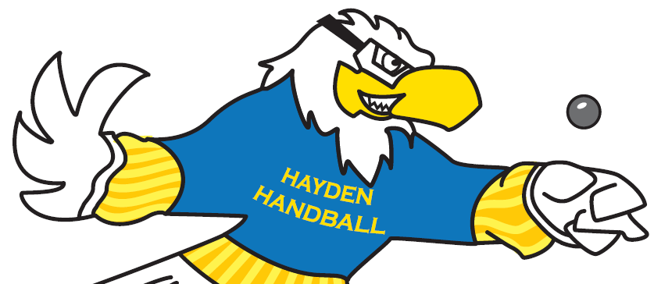

Big Ball Handball Classic

November 18th, 2017

8:00 am – 5:00 pm

Carl Hayden High School, 3333 W. Roosevelt St, Phoenix, AZ 85009

**2017 Hayden - Mecha Car Show Handball Classic**

**I. Entry Information (print)**

Name: ________________________________________ Age: ________ Phone: ___________________

Street Address: ______________________________________________________

City: ___________________________ State: ____________ Zip: ____________

Email: ________________________________________ **Shirt Size** (Circle): S M L XL XXL

**Questionnaire**: In the future, which would you prefer (circle): **Big Ball** **Small Ball** **Both**

**II. Entry Fee:** High School/Collegiate: $5.00, USHA Member: $15.00, Other: $20.00. Make check **payable** to Carl Hayden Handball Club, payment must be accompanied by Entry Form. **Send** to Carl Hayden Community High School, c/o Chris Hogan, 3333 W. Roosevelt Ave. Phoenix, AZ 85009. In case of rain/emergency: the event is cancelled and fees will be refunded.

**\*\*\*\*\*Entry Deadline: Must be received by November 8th, 2017\*\*\*\*\***

**III. Choose your Division & Times:** Open-A-B-C-D Guaranteed at least two matches

( ) C-D - Beginner Singles ( ) B - Intermediate Singles ( ) A - Advanced Singles ( ) Open Singles

(8:30 am – 10:30 am) (10:30 am – 12:00 pm) (10:30 am – 12:00 pm) (1:00 pm – )

*USHA rules will apply. **Eye guards are mandatory**. Seeding committee has the right to reclassify, combine, or cancel division.

**IV. Prizes:** Participation certificates for all Beginners, Trophies to the top two Finalists in the Intermediate, Advanced, and Open.

**V. Waiver and release:**  I hereby, for myself, my heirs, executors, and administrators, waive, release and forever discharge Carl Hayden High School, their officers, agents or representatives from any claim for injuries, damage, or loss incurred during my participation in the above Tournament, Nov. 18, 2017.

Participant’s Signature ____________________________________________________ Date __________

Parent/Guardian Signature _________________________________________________ Date __________

(If under 18 years old, Parent or Guardian must sign.)

**NOTE:** Tournament Director reserve(s) the right to combine/cancel any division due to insufficient entries. Director/ Hayden Principal may refuse participant's entry for any reason. **Questions?** Contact Chris Hogan: hogan@phoenixunion.org